

**PROJECT REPORT**

(Project Semester January 05 – June 30)

## Monitoring Software for Laser Based Systems

Submitted by

**Dipankar Ghosh**

**PRN: 12070121113**

Under the Guidance of

**Mr. Ravindra Singh**

**(Scientist “F”)**

Faculty Mentor Industry Mentor

**Mrs.Nisha Auti Mrs. Sweta Singh**

**(Professor) (Scientist “E”)**

# Department of Computer Science Engineering

**SYMBIOSIS INSTITUTE OF TECHNOLOGY, PUNE**

**January 2015 – June 2015**

**CONTENTS**

|  |  |
| --- | --- |
| **Introduction** | 6 |
| **Abstract** | 7 |
| **Work Industry Review** | 7 |
| **Purpose of Assignment** | 8 |
| **Job Description** | 9 |
| **Project Design** | 10 |
| **SRS (Software Requirement Specification)** | 11-15 |
| **Test Cases & Results** | 16-19 |
| **Conclusion** | 20 |
| **Future Scope of Work** | 20 |
| **References** | 20 |
| **Progress Reports** | 21-26 |

**DECLARATION**

I hereby declare that the project work entitled “Monitoring Software for Laser Based Systems” is an authentic record of my own work carried out at LASTEC, Defense Research & Development Organization (DRDO), New Delhi as requirements of six months project semester for the award of degree of B.Tech. Computer Science Engineering, Symbiosis Institute of Technology, Pune, under the guidance of Mrs.Sweta Singh and Mrs.Nisha Auti, during January to June 2015.

Dipankar Ghosh

12070121113

Date: ___________________

Place: New Delhi

Certified that the above statement made by the student is correct to the best of our knowledge and belief.

**Mrs. Nisha Auti Mrs. Sweta Singh**

**Assistant Professor LASTEC - Scientist ‘E’**

**Faculty Guide Industry Mentor**

**CERTIFICATE ACKNOWLEDGEMENT**

I am blissful to express my deep sense of gratitude to Mr. Ravindra Singh Sc. ‘F’ who gave me the opportunity to work in Control Electronics Group (CEG) to gain applied knowledge.

I would like to thank Mrs. Sweta Singh, Scientist’E’, LASTEC, DRDO for giving me the opportunity of undergoing my internship program with her guidance. I wish to express my gratitude to the entire LASTEC team for guiding and helping me throughout my Internship program, without their support, I wouldn’t have been able to complete this project. Her constant interaction, expert guidance and valuable suggestions helped me to complete this project successfully.

I wish to thank Prof. Shraddha Phansalkar, HOD, CS & IT Department, Symbiosis Institute of Technology Pune for providing us with excellent training facility and great learning opportunity. I wish to thank my faculty mentor, Mrs. Nisha Auti, Assistant Professor Symbiosis Institute of Technology Pune, for her invaluable support and guidance throughout the Internship programme.

I express my heartfelt gratefulness to my teachers, parents and friends for their

wishes and contributions towards carrying out this endeavor.

This internship semester has really been a great experience, with lot of fun and learning and for this I would really like to thank DRDO and Symbiosis Institute of Technology for providing me such a great opportunity. I would also like to thank my colleagues and friends at DRDO, LASTEC for being a constant source of inspiration.

1. **INTRODUCTION**

Defence Research & Development Organisation (DRDO) works under Department of Defence Research and Development of Ministry of Defence.

DRDO is working in various areas of military technology which include aeronautics, armaments, combat vehicles, electronics, instrumentation engineering systems, missiles, materials, naval systems, advanced computing, simulation and life sciences.

DRDO while striving to meet the Cutting edge weapons technology requirements provides ample spinoff benefits to the society at large thereby contributing to the nation building.

Laser Science & Technology Centre (LASTEC), Delhihas its origin as Defence Science Laboratory (DSL) established as a nucleus laboratory of DRDO in 1952.

In the beginning DSL operated from National Physical Laboratory (NPL) building. Later in 1960, it was shifted to Metcalfe House.

In 1982, the DSL moved to its new technical building in Metcalfe House complex and was renamed as Defence Science Centre (DScC). In 1999, in view of the R&D thrust shifting to development of lasers and optoelectronics systems & related technologies, the laboratory was rechristened as Laser Science & Technology Center (LASTEC).



With so many activities to its credit and with successful achievement of results LASTEC

is heading towards becoming a pioneer center of laser activities in India.

1. **ABSTRACT**

The present project was carried out in the LASTEC department of DRDO with a view to develop a monitoring software for laser based system.

The purpose of this monitoring software is to have an application which is responsible for:

1. Monitoring of system parameters.
2. Provision of active databases.
3. Capability to store subsystem parameters as per the requirement.
4. Should contain a client-server module.
5. Integration of the entire system with subsystem parameter whose monitoring has to be carried out.
6. Capability of logging the data for post analysis.
7. Should be able to work offline as well as online.
8. **WORK INDUSTRY REVIEW**

**LASTEC’s** (Laser Science & Technology Centre) vision isto be a centre of excellence in the field of lasers and their defence applications**.**

Their mission is to develop high power laser sources and related technologies for directed energy applications.

* Develop technologies and systems for laser support measures like CBRNE detectors, weapon locators, laser illuminators etc.
* Carry out advanced directed research in the fields of lasers and photonics.

The main aim is to develop Laser based systems for defence applications and for the testing of these Laser based systems the department requires software developed by technical developers.

The task assigned was to develop such a single independent module that would test a Laser System currently used by the LASTEC department.

1. **PURPOSE OF ASSIGNMENT**

The Purpose of the project was to create a monitoring software for testing of laser based systems.

This software was to be built in C++, C# or any language with C module as the department used only C based software.

This software should have independent features like:

* Client-Server Module.
* Database (OLEDB Connectivity) Module.
* Data Transfer Module.
* Logging (Excel Feature) Module.

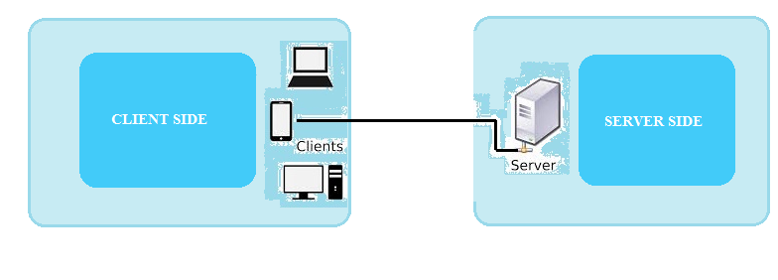

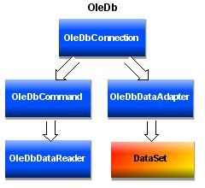

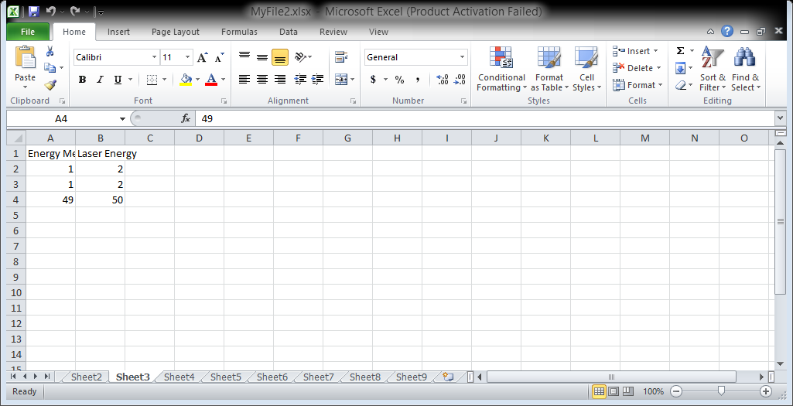

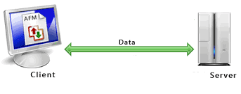

**MAJOR TASKS**

* Designing User Interface for display of database tables within data grid views.
* Connecting the data grid views with the assigned database.
* Transferring data from server side to client side.
* Entering the data transferred into the data grid view.
* Logging the data received at client side in MS-Excel worksheets.
* Testing the application.

1. **JOB DESCRIPTION**

Institution Name: DRDO (Defense Research & Development Organization).

Job Title : Trainee.

Pay Range : -nil-

Joining Date : 05-Jan-2015

End Date : 30-June-2015

Timing : 9:30 A.M. to 5:00 P.M.

Department : LASTEC (Laser Science & Technology Centre).

Location : MetCalfe House, Civil Lines, Delhi-110054

Job Summary: Task assigned is to develop a monitoring software for testing of Laser

Based Systems.

1. **PROJECT DESIGN**

The project “**Monitoring Software for Laser Based Systems**” involved designing, development and coding in C# on Visual Studio 13.

This project which was carried out for 5 months consisted of

* Designing of user interface in visual studio.
* OLEDB connectivity for databases.
* Database development using MS-Access.
* Client-server functionality.
* Logging of data in MS-Excel
* **WORKING**
* The server side is first executed.(Fig. 2, pg. 17)
* Laser subsystem is selected at the client side after execution.

(Fig. 4, pg. 18) (Fig. 1, pg. 16)

* A signal from the client side is sent to the server side.(Fig. 2a,pg. 17)
* The server sends the data which it receives from the user or a third party application to client.(Fig. 5, pg. 19)
* The client side then receives this data.(Fig. 4,pg. 18)
* The data can be transferred in the particular data grid view. (Fig. 4,pg. 18)
* The data can then be logged in a MS-excel worksheet.(Fig 6.,pg 19)

The snapshots of the execution have been showed in order in Testing & Results section. (pg. 16)

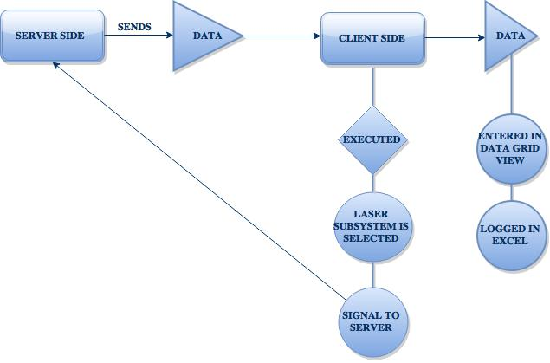

1. **SRS (SOFTWARE REQUIREMENT SPECIFICATION)**

* **HIGH LEVEL DESIGN**

1. The first requirement was to design a GUI showing different subsystems.

* The GUI was to be developed using windows form application.

1. The second requirement was to create a database which could be linked with the GUI.

* The database was created using MS-Access.
* This database contained the subsystem parameters details.

1. The third requirement was to develop a client server module.

* This module was created separately and then inculcated with the main code.

1. The fourth requirement was to transfer the data from server to client side in particular order of subsystem parameters.

* Each subsystem has a different set of parameters and the data had to be displayed accordingly in the data grid view.

1. The fifth requirement was to generate a logging feature for post analysis.

* This logging feature as created using MS-Excel.
* **TOOLS AND TECHNOLOGY USED**
* **C# Language:** The name "C sharp" was inspired by musical notation where a sharp indicates that the written note should be made a semitone higher in pitch.

C# (pronounced as see sharp) is a multi-paradigm programming language encompassing strong typing, imperative, declarative, functional, generic, object-oriented (class-based), and component-oriented programming disciplines.

It was developed by Microsoft within its .NET initiative and later approved as a standard by Ecma (ECMA-334).

C# is one of the programming languages designed for the Common Language Infrastructure & is intended to be a simple, modern, general-purpose, object-oriented programming language.

Its development team is led by **Anders Hejlsberg**. The most recent version is **C# 5.0**, which was released on August 15, 2012.

* **Microsoft Visual Studio 2013:** It is an integrated development environment (IDE) from Microsoft. It is used to develop computer programs for Microsoft Windows, as well as web sites, web applications and web services.

Visual Studio uses Microsoft software development platforms such as **Windows API**, **Windows Forms**, **Windows Presentation Foundation**, **Windows Store and Microsoft Silverlight**.

The final release of **Visual Studio 2013** became available for download on 17 October 2013 along with .NET 4.5.1.

Visual Studio 2013 officially launched on 13 November 2013 at a virtual launch event keynoted by S. Somasegar and hosted on events.visualstudio.com

* **Windows Forms:** Windows Forms (Win Forms) is the name given to a graphical (GUI) class library included as a part of Microsoft .NET Framework, providing a platform to write rich client applications for desktop, laptop, and tablet PCs.

While it is seen as a replacement for the earlier and more complex C++ based Microsoft Foundation Class Library, it does not offer a comparable paradigm and only acts as a platform for the user interface tier in a multi-tier solution.

* **Windows Forms Application:** It is an event-driven application supported by Microsoft's .NET Framework.

Unlike a batch program, it spends most of its time simply waiting for the user to do something, such as fill in a text box or click a button.

Windows Forms provides access to native Windows User Interface Common Controls by wrapping the extant Windows API in managed code & with the help of Windows Forms, the .NET Framework provides a more comprehensive abstraction above the Win32 API than Visual Basic or MFC did.

* **Microsoft Access:** also known as **Microsoft Office Access**, is a database management system from Microsoft that combines the relational Microsoft Jet Database Engine with a graphical user interface and software-development tools.

It is a member of the Microsoft Office suite of applications, included in the Professional and higher editions or sold separately**.**

Software developers and data architects can use Microsoft Access to develop application software, and "power users" can use it to build software applications. Like other Office applications, Access is supported by Visual Basic for Applications (VBA) & An Access database (either a .mdb file or a .accdb file) could be connected by using Visual Studio.

* **Microsoft Excel:** It is a spreadsheet application developed by Microsoft for Microsoft Windows, Mac OS X, and iOS.

It features calculation, graphing tools, pivot tables, and a macro programming language called Visual Basic for Application & has been a very widely applied spreadsheet for these platforms, especially since version 5 in 1993, and it has replaced Lotus 1-2-3 as the industry standard for spreadsheets. Excel forms part of **Microsoft Office**.

Visual Studio provides project templates you can use to create document-level customizations and application-level add-ins for Microsoft Office Excel. You can use these solutions to automate Excel, extend Excel features, and customize the Excel user interface (UI).

* **SQL:** Structured Query Language is a special-purpose programming language designed for managing data held in a relational database management system (RDBMS), or for stream processing in a relational data stream management system (RDSMS).

**“SQL was used as an option initially while developing the database feature but later on MS-Access met our requirements and was used in the final section”**

* **HARDWARE TOOLS**

**Processor**:Intel® Core™ i5-337U.

**RAM**: 512MB.

**Hard Disk Capacity**: 40 GB Hard Disk space and above.

* **CODE METRICS**

|  |  |  |  |
| --- | --- | --- | --- |
| **Project** | **Configuration** | **Maintainability Index** | **Lines of Code** |
| Client | Debug | 75 | 628 |
| Server | Debug | 79 | 164 |

A **green rating is between 20 and 100** and indicates that the code has good maintainability.

* **CODE SNIPPETS**

1. **TEST CASES & RESULT**

**Results:**

The following snapshots showed the work carried out during testing shown below:

*Snapshot I:*

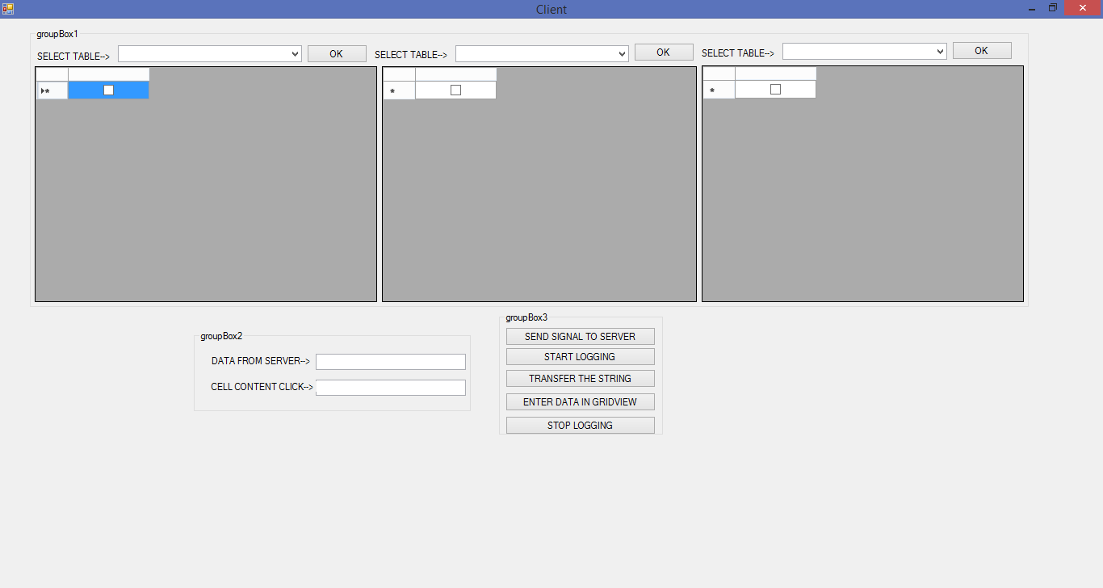

.

*Figure 1: Client Side GUI*

* The client side GUI contains 3 data grid views and separate combo boxes via which subsystems can be selected.
* Separate group boxes are designed which contain textboxes and buttons.

*Snapshot II:*

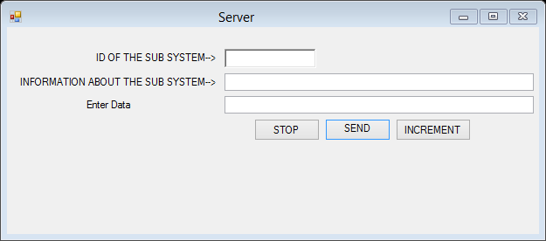

*Figure 2: Server Side GUI*

**Tested Experiment Results:**

* Data being sent from the Server side has to be received from Client side.

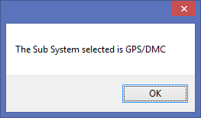

Figure 2a : Signal at Server side.

* A message box is displayed to show the sub system selected by the client at the server side so that the server side can send data accordingly.

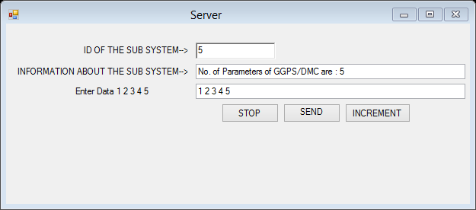

*Figure 3: Server Side Testing*

* Data is received at Client side.

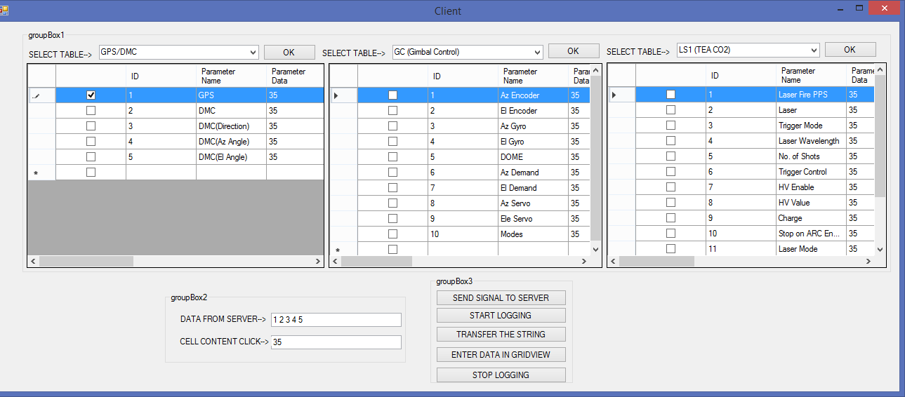

*Figure 4: Client Side Testing 1*

* The Data is sent 49 50 from Server Side.

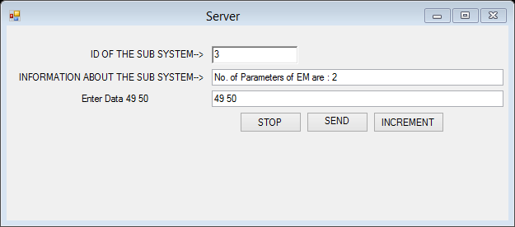

*Figure 5: Server side data sending*

* The Server side GUI has textboxes and buttons via which data can be sent to the client side.
* Logging the data received in MS-Excel worksheets



*Figure 6: Logging data in MS-Excel Worksheet*

1. **CONCLUSION**

The Monitoring Software Project has been developed as per the stated requirement and has met the objectives assigned within the stipulated time period.

Current objectives are to 1) Inculcate the developed software with a third party application 2) Automation of the software after the software is colluded with the third party application.

1. **FUTURE SCOPE OF WORK**

There is a lot of scope when it comes to work related to Laser Science.

Various different type of Laser Systems need support software for its data storage hence innumerous number of Monitoring softwares could be developed.

In the future this tool could work in a way that there is no need for manual intervention.

This code can further be modified and completely automated also a module for direct entry of data from a third party application could be developed.

* Further development of the monitoring software in terms of automation.
* Could be added to a part of a bigger module.
* Can be augmented and a new monitoring software could be devised.
* Simultaneous data logging system can be upgraded.

1. **REFERENCES**

* <http://www.microsoftvirtualacademy.com/product-training/visual-studio-courses>
* <https://msdn.microsoft.com/en-us/library/ms171893.aspx>
* <http://www.microsoftvirtualacademy.com/training-courses/what-s-new-in-visual-studio-2013-jump-start>
* <http://stackoverflow.com/>
* <http://www.w3schools.com/>
* <https://msdn.microsoft.com/en-us/library/360kwx3z(v=vs.90).aspx>
* <https://www.youtube.com/watch?v=Oxg6ciIcO3U>
* <http://blogs.msdn.com/b/zainnab/archive/2011/05/26/code-metrics-maintainability-index.aspx>

1. **PROGRESS REPORTS**

Below are the visit reports which have been signed by my mentor.

**Progress Report I**

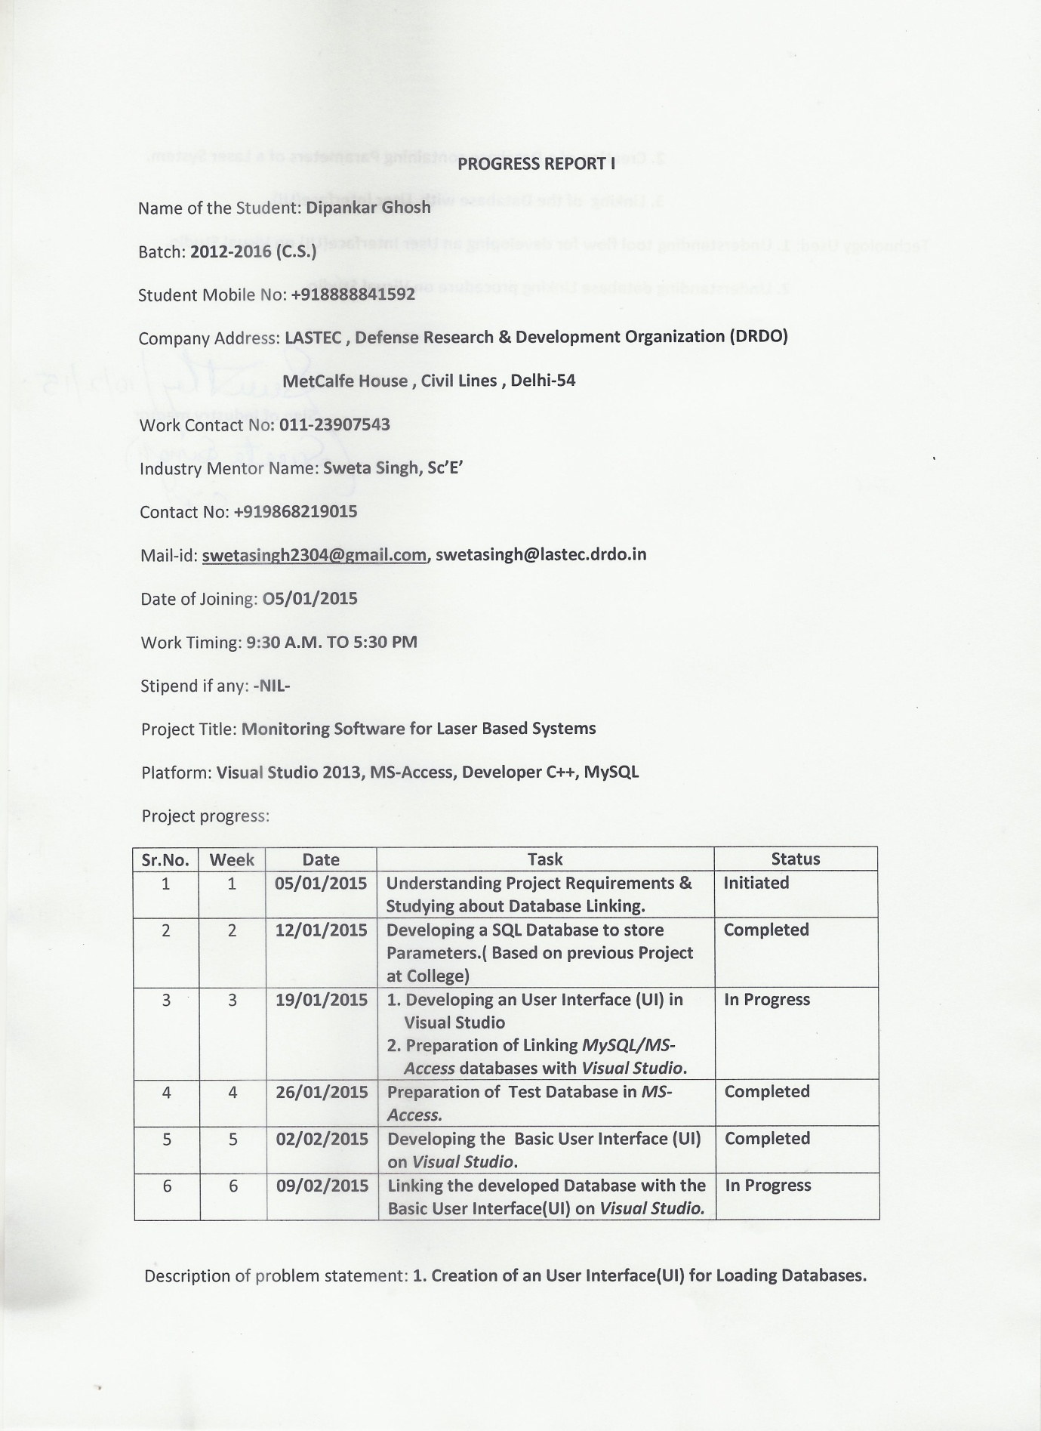

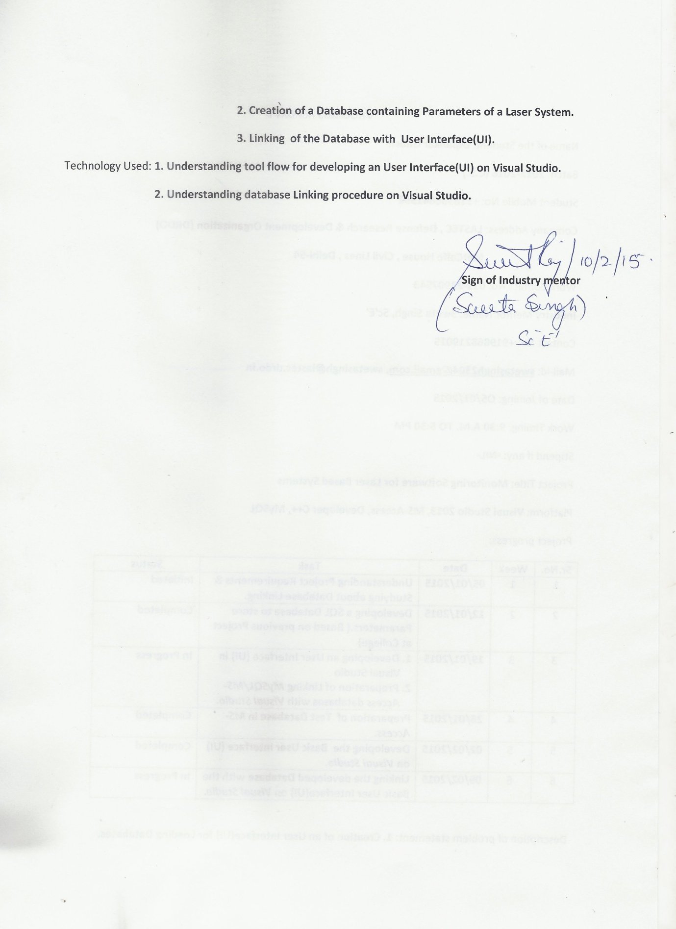



**Progress Report II**

